Flow

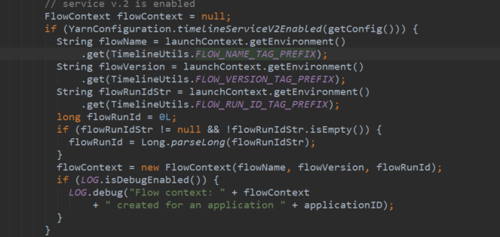

FlowContext

container-localizer.log.level